Accredited Professional Quantity Surveyor (APQS)
RECENT PASSPORT-SIZE
PHOTO*
Application Form
APPLICANT DETAILS (please print clearly)
Title: ◻ Mr ◻ Ms ◻ Miss ◻ Mrs ◻ Other: ……………..….…..………
Given Names (first name): ………………..………....................Family Name (surname): ………………….…..……….……………
Employer name: ……………………………………………………………………….
Position: ………………………………………
Correspondence Address: ………………………………………………………………………………………………………….….…………
….…………………………..………………..…….……………………..…………………………………………… Postcode: .………..…...…….
Work / Home Phone: …………………………..…………….……………Mobile Phone: ………..…….…..……..………….………..
Email: …………………………..………………………………………………… Member No (if applicable): …………..………………
*The recent passport size photo should be no more than 3 months old.
BACKGROUND STATEMENT
In the last 10 years, have you been charged with any criminal or civil offence which is not yet before a court, or yet to be fully determined by a court or still pending before a court, in Singapore or Overseas?
◻ Yes ◻ No
If yes, please provide details
………………………………………………………………………………………………………………………………………………………….
………………………………………………………………………………………………………………………………………..…………………
In the last 10 years, have you been convicted, found guilty or otherwise had any criminal or civil offence proven against you (even if a conviction was not recorded) in Singapore or overseas?
◻ Yes ◻ No
If yes, please provide details
………………………………………………………………………………………………………………………………………………………….
……………………………………………………………………………………………….…………………………………………………………
(A criminal offence is an offence for which you received a Court Attendance Notice and does not include minor traffic offences such as a parking or low range speeding ticket).

SISV MEMBERSHIP
SISV Membership is not a mandatory requirement for APQS designation. Applicants may elect not to be full SISV Professional members upon successful completion of all APQS requirements and may elect to only be APQS designated. Different membership rights, privileges and rates will apply.
Are you currently an SISV Member?
◻ Yes ◻ No

Do you currently have any SISV subscription arrears?
◻ Yes ◻ No

Do you intend on continuing to be / becoming a SISV member, upon successfully attaining the APQS designation?
◻ Yes ◻ No

PROFESSIONAL MEMBERS OF OTHER INTERNATIONAL RECOGNISED PROFESSIONAL QS INSTITUTIONS (with SISV reciprocity arrangement through reciprocity or other agreements)
Please note that applicants who rely on other professional memberships for their APQS application, must continue to remain as a member of that Professional QS Institute, in their annual renewal of their APQS designation, if they chose not to become SISV members.

Have you provided a Letter of Good Standing from your respective Professional QS Institute, together with this application?
◻ Yes ◻ No

SISV APQS Tier
◻ Tier 1 – Associate Director / Contracts Director (and above - Directors/Partners/Principals, etc.)
◻ Tier 2 - Senior QS / Senior Contracts/Cost Manager
◻ Tier 3 – Quantity Surveyor / Contracts/Cost Manager
◻ Tier 4 - Assistant QS / Assistant Cost Manager

Please fill out Skills Framework Competencies Table for Tier 1 / 2 / 3 / 4
- Please review the APQS Application Prerequisites
- Please review the Skill Framework Guideline details for the level of experience required

SUPERVISOR DECLARATION (FOR TIER 4 ONLY).
I support and endorse the above APQS application to SISV, and confirm the experience and skills levels declared in the application, to be accurate.

Name: ……………………….......………………… Signature: ………………..……………….…….…….… Date: ……… / ………… / …………..

APPLICANT DECLARATION
I do solemnly declare that:
- all the particulars furnished by me are true and correct;
- I will comply with the Institute’s Constitution; By-laws; Rules for maintaining the Accredited Professional Quantity Surveyor designation; and Code of Professional Conduct of SISV QS Division, as amended from time to time;
- I have not had a breach of any items of the Code of Professional Conduct of SISV QS Division within the last 2 years; and
- I agree that SISV may disclose my full name, membership status, to any relevant enquiring bodies /parties

I certify that I comply with the pre-requisites for maintaining the APQS designation.

Signature: ………………..………………………………………………………....... Date: ……… / ………… / ……………
SUBMITTING APPLICATION
Please send completed Application Form & Application Fee (Refer to Appendix 1) to:

BY MAIL:
Singapore Institute of Surveyors and Valuers,
QS Division
110 Chiat Hong Building
#09-00
Singapore 188968

BY EMAIL: APQS@sisv.org.sg

PAYMENT DETAILS
PayNow |  | PayNow (UEN No.: S82SS0045E)  Confirm entity name as SINGAPORE INSTITUTE OF SURVEYORS & VALUERS  Indicate APQS Application in UEN / Bill Reference
Bank Transfer |  | DBS Current Account no.: 007-005007-0  Bank Code: 7171 | Branch Code: 007  SWIFT CODE: DBSSSGSG  Please indicate APQS Application as reference when transferring
By Cheque |  | Crossed cheque payable to "Singapore Institute of Surveyors and Valuers".  Please indicate your name and APQS Application as reference on the back of the cheque

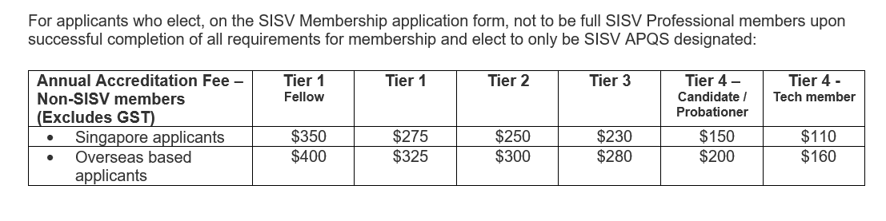
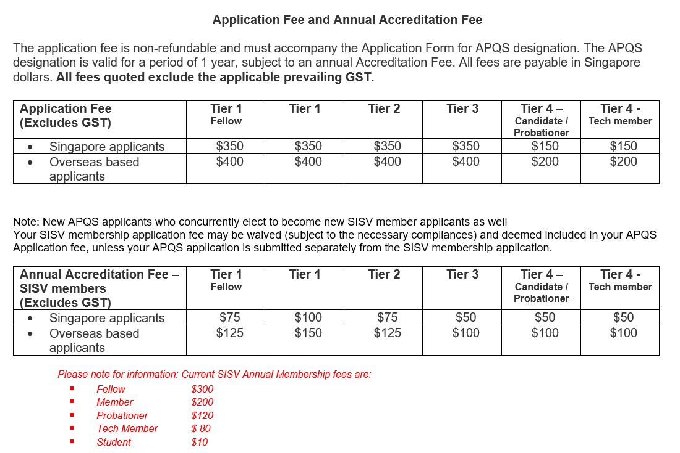
Appendix 1

